MEGA HEAD and MEGA AV installation instructions..

NOTE: These instructions pertain to WinDOZE 98

1. Download the BIGAV.EXE program
2. Download the MEG.EXE program

When downloading the above programs, you will want to download them into the VPLACES folder.
If your hard drive is C:, then you will want to download the fiels into C:\Program Files\Vplaces

When the download box appears... click on "Save this program to disk", then click OK
Then when the SAVE AS window appears... Locate "Program Files" and click on it.. then locate
"Vplaces" and click on it.. then click OK.. This will save the downloaded file to that folder.

NOTE: The files can be located at http://www.geocities.com/SouthBeach/Lounge/2773/links.html

The MEG.EXE program is a yahtzee game, that allows you to display MEGA AV's.
The BIGAV.EXE program is a patch for VPLACES that allows you to use MEGA AV's in your gallery

After you have downloaded the two programs, close VP completely.
Then execute MEG.EXE. To execute the program.. click on START... then click on RUN... then click on BROWSE... and locate the MEG.EXE file in the folder that you downloaded it into. Once you have located
the file MEG.EXE.. click on OK to execute it (run it)...

Next, execute the BIGAV.EXE program in the same was as you did MEG.EXE

Now start VP.

Make sure you are NOT in observe, eg that your av is visible in the room...
Right click on your AV... and then click START A GAME... you should then see the GAMES LIST box
as shown below..

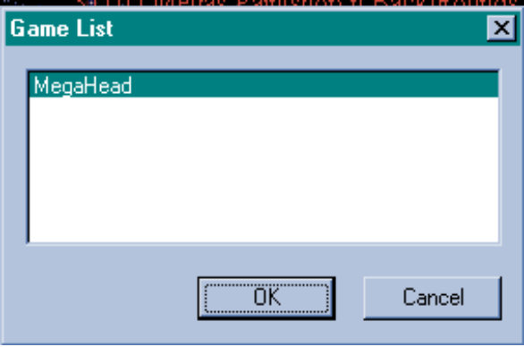

Now click OK..
And the box shown below should now appear...

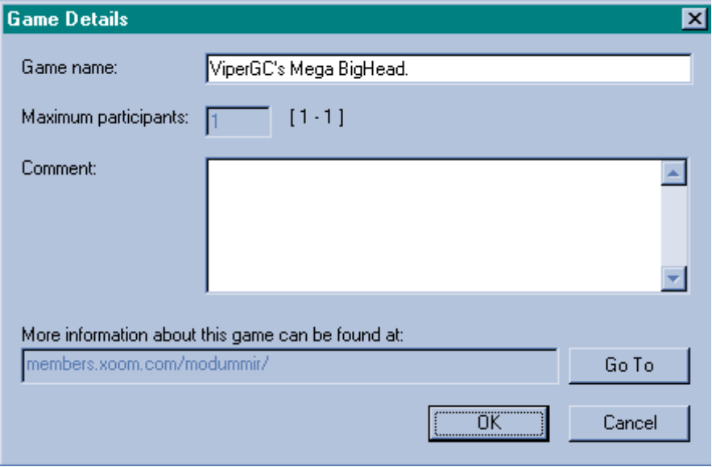

Now click OK in the box above...
And you should see the following screen....

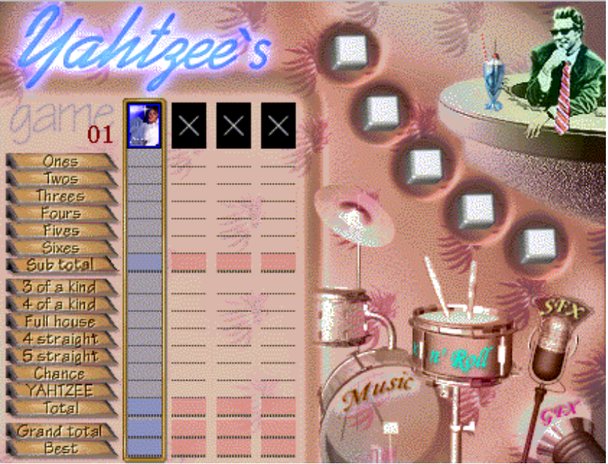

While you are here on the screen above.. you will want to turn off the sounds...
Right click anywhere in the above screen.. and you will see the following...

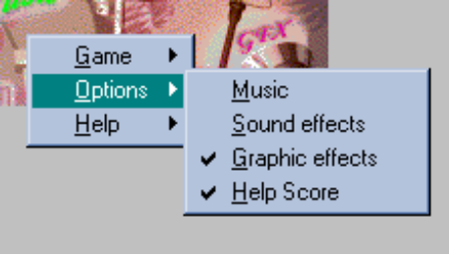

Turn OFF Music and Sound Effects..

Now.. on the lower portion of the VP screen.. you will see 3 tabs.... CHAT ROOM... WHAT'S HOT... GAMES..... The GAMES tab will be highlighted right now... to return to the chat room... click the
CHAT ROOM tab...

Your AV should now be a MEGA.. You will have to start the game each time you want to become MEGA
once you start the VP program. Since your av is still a small one.. it will be MEGA sized.. but will look rather
grainy, so you will need to get some MEGA av's..

GETTING A MEGA AV ON THE SCREEN

Right click on your AV.. then click EDIT IDENTITY.. then click CHANGE... you should now see
the AV's... . as you did originally.. only they will be MEGA sized...

When you get new AV's... download them into the \program files\vplaces\exts\gallery folder... this is the
gallery that is displayed when you EDIT IDENTITY.

MOVING THE MEGA HEAD ON SCREEN

Once you are mega, move the mouse cursor on top of the AV.. near the edges.. you will
find two different yellow banners. Suppose your nick is ViperGC... then you will find
one yellow banner that says "ViperGC"... and another banner that says "ViperGC's Mega Bighead",
this is the one you want... If you move the mouse until you see the second banner and then
click the left mouse button and HOLD it down.. you can move the mega AV on screen...

To return to the smaller av's. simply click on the AV near the center and hold the mouse button
down and move the av.. it will become small again.

--------------------------------------------------------------------------------------------------------------------
This file was put together by ViperGC to help newbies get started with MEGA AV's...
Visit my links page at....

http://www.geocities.com/SouthBeach/Lounge/2773/links.html

